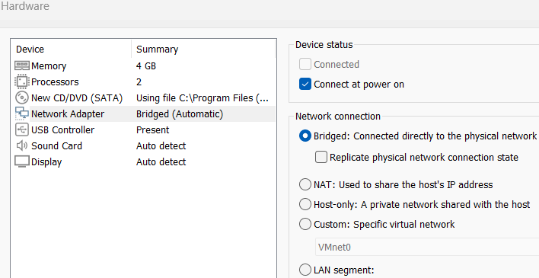
1. Prerequisites & VM Setup
Create 3 virtual machines (one Control Plane, two Worker) with the following minimum specifications:
- OS: Ubuntu 24.04 LTS
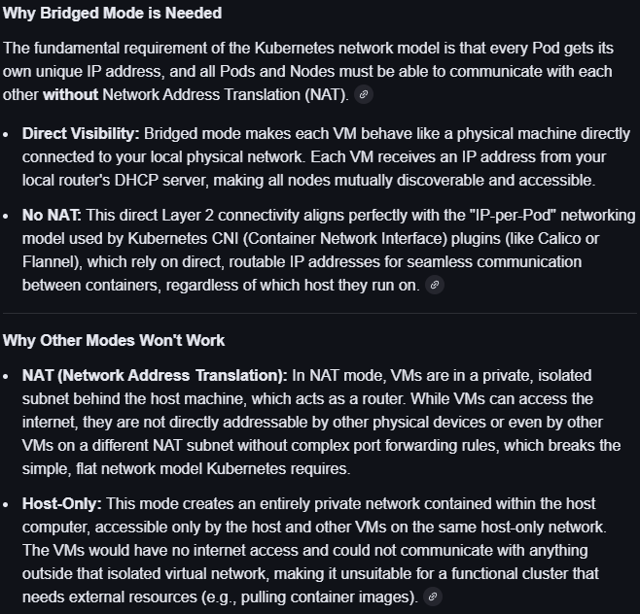
- Hardware: 2 CPUs and 4 GB RAM each for the master node and worker nodes.
- Networking: Set VMware network adapter to Bridged Mode so each VM receives its own IP address on your local network.
- Storage: 25-40 GB for control plane node. 20-100GB for worker node. Standard partitioning (None).
- Unique IDs: Ensure each VM has a unique hostname, MAC address, and product UUID.

2. VM Preparation (All Nodes)
- On all nodes, set static IP. Make sure it persists across reboot.
- On all nodesdisable swap to ensure proper Kubernetes scheduling.
swapoff -a
sudo sed -i '/ swap / s/^\(.*\)$/#\1/g' /etc/fstab

# or just manually comment the swap entry line in fstab
# confirm its disabled with “swapon –show”. Shouldnt have any output.
- Configure the kernel to allow iptables to see bridged network traffic. They ensure that the necessary kernel modules are loaded and that network traffic bridging works correctly with Kubernetes iptables rules.
cat <<EOF | sudo tee /etc/modules-load.d/k8s.conf
overlay
br_netfilter
EOF

sudo modprobe overlay
sudo modprobe br_netfilter

# sysctl params required by setup, params persist across reboots
cat <<EOF | sudo tee /etc/sysctl.d/k8s.conf
net.bridge.bridge-nf-call-iptables = 1
net.bridge.bridge-nf-call-ip6tables = 1
net.ipv4.ip_forward = 1
EOF

# Apply sysctl params without reboot
sudo sysctl --system

# Verify that the br_netfilter, overlay modules are loaded by running the following commands:
lsmod | grep br_netfilter
lsmod | grep overlay

# Verify that the net.bridge.bridge-nf-call-iptables, net.bridge.bridge-nf-call-ip6tables, and net.ipv4.ip_forward system variables are set to 1 in your sysctl config by running the following command:
sysctl net.bridge.bridge-nf-call-iptables net.bridge.bridge-nf-call-ip6tables net.ipv4.ip_forward

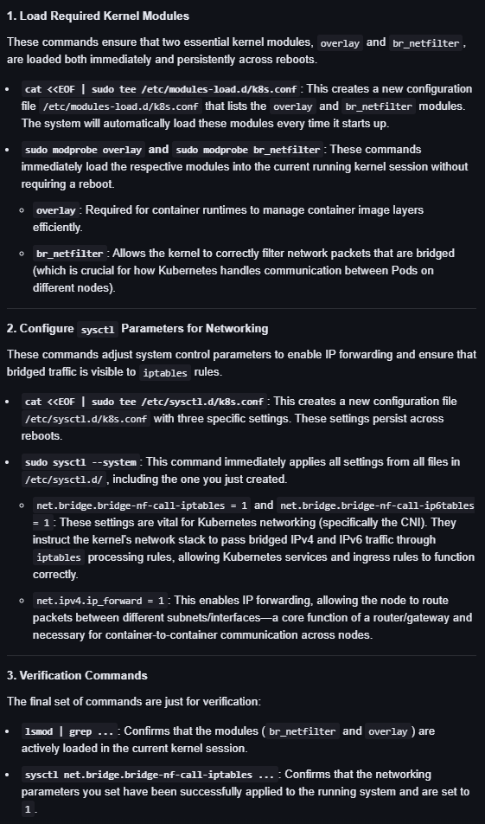

- Install a container runtime; containerd is a standard choice. After installation, configure containerd to use the SystemdCgroup driver. Install runc. Install cni plugin. Configure crictl to work with containerd.

curl -LO https://github.com/containerd/containerd/releases/download/v1.7.14/containerd-1.7.14-linux-amd64.tar.gz
sudo tar Cxzvf /usr/local containerd-1.7.14-linux-amd64.tar.gz
curl -LO https://raw.githubusercontent.com/containerd/containerd/main/containerd.service
sudo mkdir -p /usr/local/lib/systemd/system/
sudo mv containerd.service /usr/local/lib/systemd/system/
sudo mkdir -p /etc/containerd
containerd config default | sudo tee /etc/containerd/config.toml
sudo sed -i 's/SystemdCgroup \= false/SystemdCgroup \= true/g' /etc/containerd/config.toml
sudo systemctl daemon-reload
sudo systemctl enable --now containerd

# Check that containerd service is up and running
systemctl status containerd

curl -LO https://github.com/opencontainers/runc/releases/download/v1.1.12/runc.amd64
sudo install -m 755 runc.amd64 /usr/local/sbin/runc

curl -LO https://github.com/containernetworking/plugins/releases/download/v1.5.0/cni-plugins-linux-amd64-v1.5.0.tgz
sudo mkdir -p /opt/cni/bin
sudo tar Cxzvf /opt/cni/bin cni-plugins-linux-amd64-v1.5.0.tgz

sudo crictl config runtime-endpoint unix:///var/run/containerd/containerd.sock
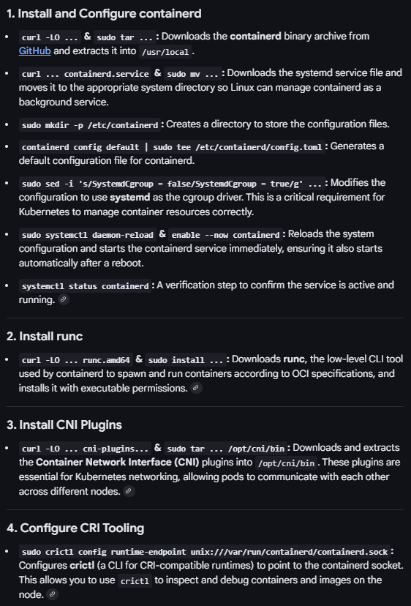

3. Install Kubernetes Tools (All Nodes) - Install the essential Kubernetes components: kubeadm, kubelet, and kubectl on all nodes. Add the Kubernetes APT repository key and repository, update your package lists, and then install the tools. Finally, hold the package versions to prevent unintended upgrades.
sudo apt-get update
sudo apt-get install -y apt-transport-https ca-certificates curl gpg

curl -fsSL https://pkgs.k8s.io/core:/stable:/v1.29/deb/Release.key | sudo gpg --dearmor -o /etc/apt/keyrings/kubernetes-apt-keyring.gpg
echo 'deb [signed-by=/etc/apt/keyrings/kubernetes-apt-keyring.gpg] https://pkgs.k8s.io/core:/stable:/v1.29/deb/ /' | sudo tee /etc/apt/sources.list.d/kubernetes.list

sudo apt-get update
sudo apt-get install -y kubelet=1.29.6-1.1 kubeadm=1.29.6-1.1 kubectl=1.29.6-1.1 --allow-downgrades --allow-change-held-packages
sudo apt-mark hold kubelet kubeadm kubectl

kubeadm version
kubelet --version
kubectl version –client

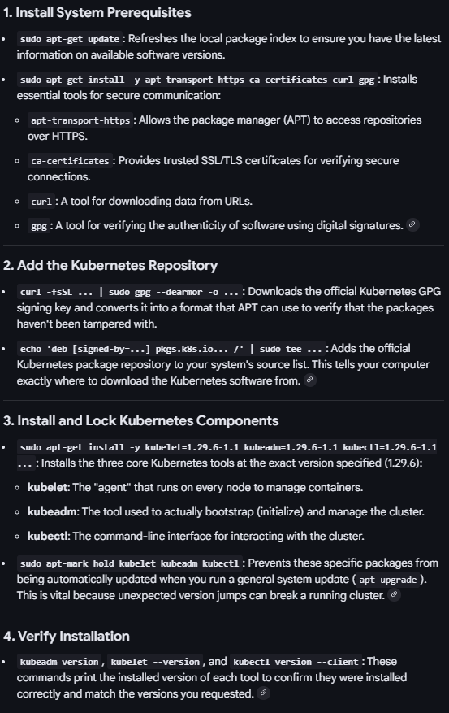

4. Initialize the Cluster (Control Plane Only)
- On the master node, initialize the cluster using kubeadm init, specifying the desired Pod network CIDR. After initialization, copy the necessary configuration files to allow kubectl to function. Be sure to save the kubeadm join command provided in the output for later use with worker nodes.
sudo kubeadm init --pod-network-cidr=10.244.0.0/16 --apiserver-advertise-address=192.168.1.5 --node-name master

--apiserver-advertise-address=192.168.1.5 This flag specifies the specific IP address of the current control plane node that all other nodes and external systems will use to communicate with the Kubernetes API server.
--pod-network-cidr=10.244.0.0/16 (or a similar non-conflicting range) This defines the large private IP range from which the cluster will allocate IPs for all your Pods. This range must not overlap with your existing physical network (which is 192.168.1.0/24).
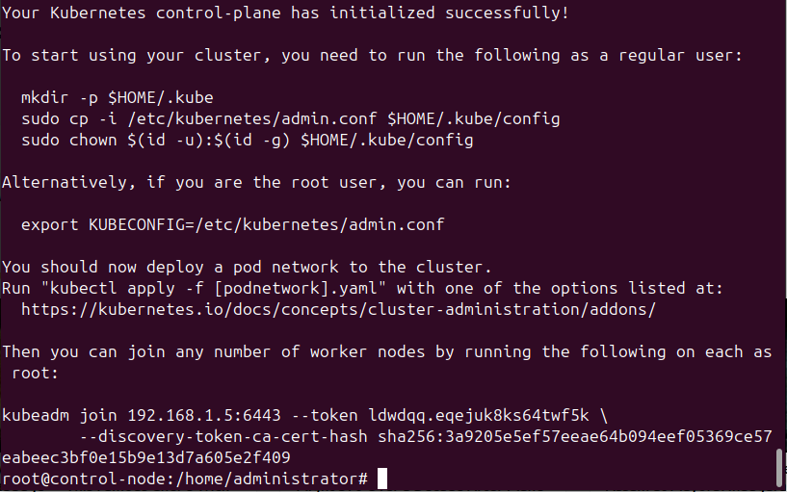

- Prepare kubeconfig
mkdir -p $HOME/.kube
sudo cp -i /etc/kubernetes/admin.conf $HOME/.kube/config
sudo chown $(id -u):$(id -g) $HOME/.kube/config

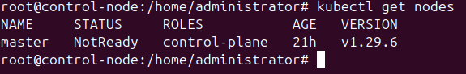
master node will be not ready state as no CNI is installed yet.

5. Install Pod Network (CNI)
Install a Container Network Interface (CNI) plugin on the master node to enable communication between Pods. Calico is a common choice. Apply the Calico manifests; you may need to adjust the configuration file to match your specified pod-network-cidr.
kubectl create -f https://raw.githubusercontent.com/projectcalico/calico/v3.28.0/manifests/tigera-operator.yaml

curl https://raw.githubusercontent.com/projectcalico/calico/v3.28.0/manifests/custom-resources.yaml -O

Change the cidr to 10.244.0.0/16
nano custom-resources.yaml
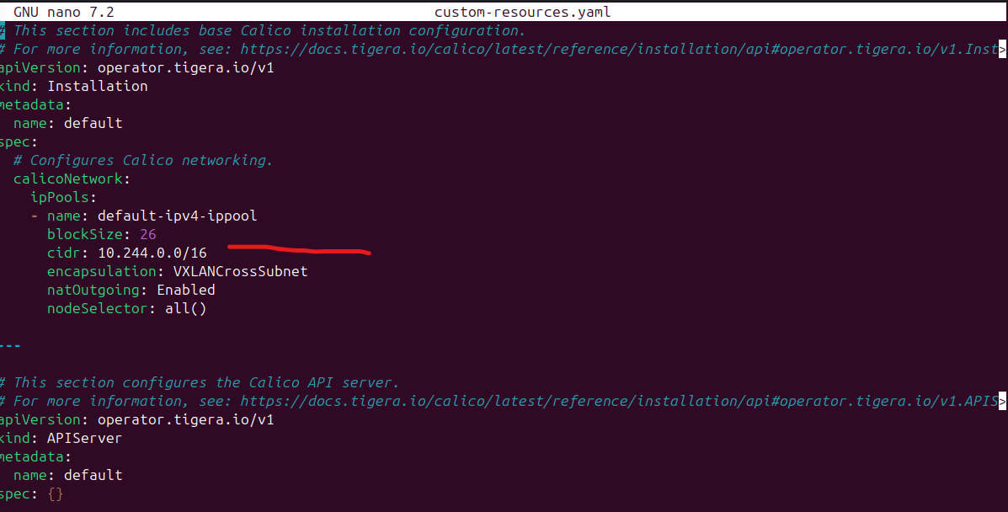
kubectl apply -f custom-resources.yaml

6. Join Worker Nodes
On each worker node, execute the kubeadm join command you saved from the initialization step to connect them to the cluster.
kubeadm join 192.168.1.5:6443 --token ldwdqq.eqejuk8ks64twf5k --discovery-token-ca-cert-hash sha256:3a9205e5ef57eeae64b094eef05369ce57eabeec3bf0e15b9e13d7a605e2f409
If earlier command was not saved, generate new token/command with “kubeadm token create –print-join-command”

Copy kubeconfig file from master node to worker nodes, so kubectl can connect from there to api server running in master node.

7. Verification - From the master node, confirm that all nodes have successfully joined the cluster and are in a Ready state using kubectl get nodes. To further test the setup, you can deploy a sample application like Nginx.

